Exercise 1: Understanding TCP Congestion Control using ns-2

We have studied the TCP congestion control algorithm in detail in the lecture (and Section 3.6 of the text). You may wish to review this before continuing with this exercise. Recall that, each TCP sender limits the rate at which it sends traffic as a function of perceived network congestion. We studied three variants of the congestion control algorithm: TCP Tahoe, TCP Reno and TCP new Reno.

We will first consider TCP Tahoe (this is the default version of TCP in ns-2). Recall that TCP Tahoe uses two mechanisms:

* A varying congestion window, which determines how many packets can be sent before the acknowledgment for the first packet arrives.
* A slow-start mechanism, which allows the congestion window to increase exponentially in the initial phase, before it stabilises when it reaches threshold value. A TCP sender re-enters the slow-start state whenever it detects congestion in the network.

The provided script, [tpWindow.tcl](https://webcms3.cse.unsw.edu.au/COMP3331/18s2/resources/17314)implements a simple network that is illustrated in the figure below.

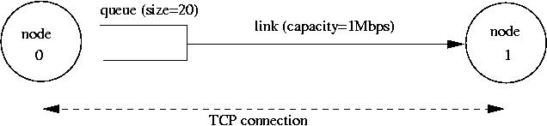

Node 0 and Node 1 are connected via a link of capacity 1 Mbps. Data traffic will only flow in the forward direction, i.e. from Node 0 to Node 1. Observe that packets from node 0 are enqueued in a buffer that can hold 20 packets. All packets are of equal size and are equal to the MSS.

The provided script accepts two command line arguments:

* the maximum value of the congestion window at start-up in number of packets (of size MSS).
* The one-way propagation delay of the link

You can run the script as follows:

$ns tpWindow.tcl <max_cwnd> <link_delay>

**NOTE:**The NAM visualiser is disabled in the script. If you want to display the NAM window (graphical interface), then uncomment the fifth line of the 'finish' procedure (i.e. remove the "#"):

proc finish {} {

global ns file1 file2

$ns flush-trace

close $file1

close $file2

#exec nam out.nam &

exit 0

}

We strongly recommend that you read through the script file to understand the simulation setting. The simulation is run for 60 seconds. The MSS for TCP segments is 500 bytes. Node 0 is configured as a FTP sender which transmits a packet every 0.01 second. Node 1 is a receiver (TCP sink). It does not transmit data and only acknowledges the TCP segments received from Node 0.

The script will run the simulation and generate two trace files: (i) *Window.tr,*which keeps track of the size of the congestion window and (ii) *WindowMon.tr*, which shows several parameters of the TCP flow.

The *Window.tr*file has two columns:

time congestion_window_size

A new entry is created in this file every 0.02 seconds of simulation time and records the size of the congestion window at that time.

The *WindowMon.tr*file has six columns:

time number_of_packets_dropped drop_rate throughput queue_size avg_tput

A new entry is created in this file every second of simulation time. The *number_of_packets_dropped*, *drop_rate*and *throughput*represents the corresponding measured values over each second. The *queue_size*indicates the size of the queue at each second, whereas *avg_tput*is the average throughput measured since the start of the simulation.

Question 1: Run the script with the max initial window size set to 150 packets and the delay set to 100ms (be sure to type "ms" after 100). In other words, type the following:

$ns tpWindow.tcl 150 100ms

In order to plot the size of the TCP window and the number of queued packets, we use the provided gnuplot script [Window.plot](https://webcms3.cse.unsw.edu.au/COMP3331/18s2/resources/17317)as follows:

$gnuplot Window.plot

What is the maximum size of the congestion window that the TCP flow reaches in this case? What does the TCP flow do when the congestion window reaches this value? Why? What happens next? Include the graph in your submission report.

**Answer: The maximum size of the congestion window is 100 packets (in the slow start phase), although the maximum congestion window we have set is 150 packets. This is because the maximum size of the queue is only 20 packets, and any redundant packets will be dropped. When the window size is increasing to large enough, it may result in time out or triple duplicate acks (or the queue becomes full). Thus, packets get dropped which means that a congestion event appears. Then the sender reduces the congestion window to 1 and the threshold to 1/2 the size of windows (the first one is 50 packets). The TCP flow enters slow start and increases rapidly (2^n exponential growth) until it hits the threshold. And then this connection enters congestion avoidance phase (i.e. AIMD). Finally, the queue becomes full again, which creates packet loss. The connection will be back to slow start and it will repeat the process as observed in the graph below.**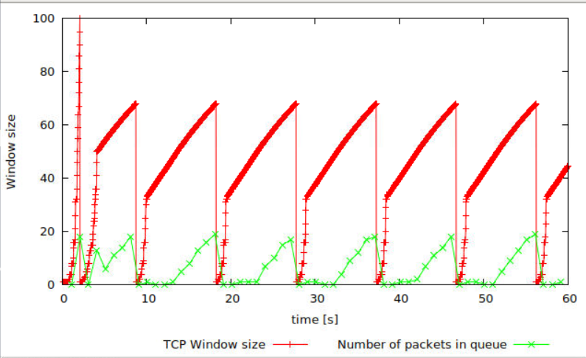

Question 2: From the simulation script we used, we know that the payload of the packet is 500 Bytes. Keep in mind that the size of the IP and TCP headers is 20 Bytes, each. Neglect any other headers. What is the average throughput of TCP in this case? (both in number of packets per second and bps)

You can plot the throughput using the provided gnuplot script [WindowTPut.plot](https://webcms3.cse.unsw.edu.au/COMP3331/18s2/resources/17318)as follows:

$gnuplot WindowTPut.plot

This will create a graph that plots the instantaneous and average throughput in packets/sec. Include the graph in your submission report.

**Answer: From the graph below, we can find that the average throughput of TCP in number of packets per second is about 190 packets per second. As for the average throughput of TCP in bps, it can be divided to two situations:**

1. **The rate at any data of TCP connection, which means that it includes header and payload data:**

**Packets * (payload data + IP header + TCP header) = 190 * (500+20+20) *8 = 802.8 Kbps.**

1. **The rate at payload data, which means that it excludes the header:**

**Packets * payload data = 190 * 500 * 8 = 760 Kbps.**

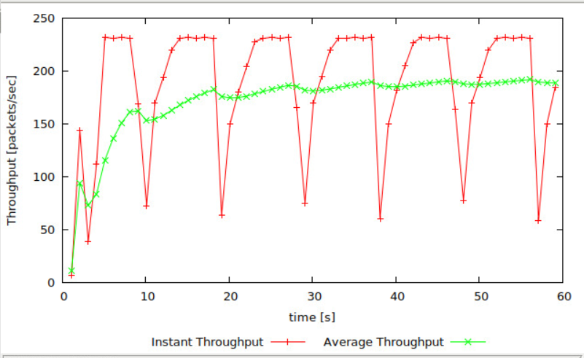

Question 3: Rerun the above script, each time with different values for the max congestion window size but the same RTT (i.e. 100ms). How does TCP respond to the variation of this parameter? Find the value of the maximum congestion window at which TCP stops oscillating (i.e., does not move up and down again) to reach a stable behaviour. What is the average throughput (in packets and bps) at this point? How does the actual average throughput compare to the link capacity (1Mbps)?

**Answer: If we want to stop the TCP oscillating, we should let the TCP not to return to the slow start phase again and again. That means the maximum congestion window size can’t become larger than the maximum queue size, otherwise, some packets are discarded and TCP will return to slow start. After several attempts, we can find that:**

1. **50 < The initial maximum congestion window size <= 66: the oscillating situation will stop after the first slow start phase. When the congestion window size reduces to half of its size, it can enter a balance situation, which means that the queue never gets full and packets are not dropped anymore.**
2. **The initial maximum congestion window size <= 50: TCP gets balance situation after slow start phase.**

**As for throughput, these two situations have similar throughput. Therefore, we will take the 50 packets as an example. At this point, the average packet throughput is close to 225 packets per sec and we just neglect the TCP and IP header. Thus, we can get:**

**The average throughput = 225 * 500 * 8 = 900 Kbps, which is almost equal to the link capacity (1 Mbps). (If we consider the TCP and IP header, we will get about 972 Kbps.)**

**Here is the graph about window changing when the congestion window size = 66:**

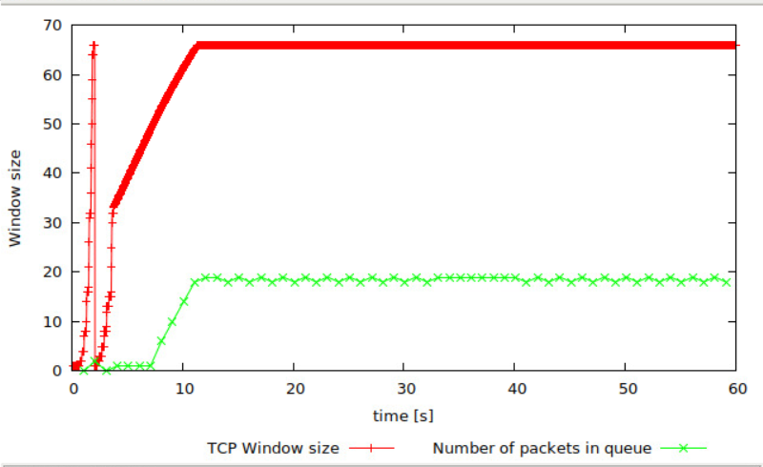

**Here is the throughput when the congestion window size = 66:**

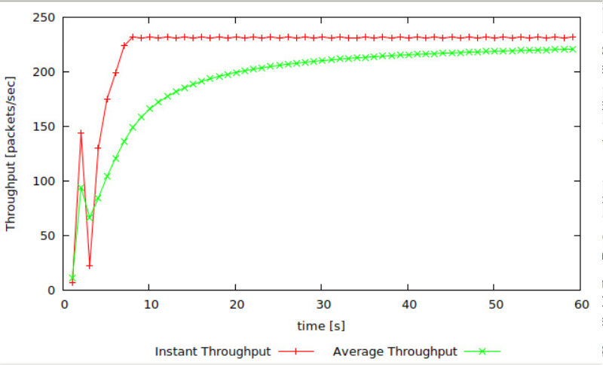

**Here is the graph about window changing when the congestion window size = 50:**

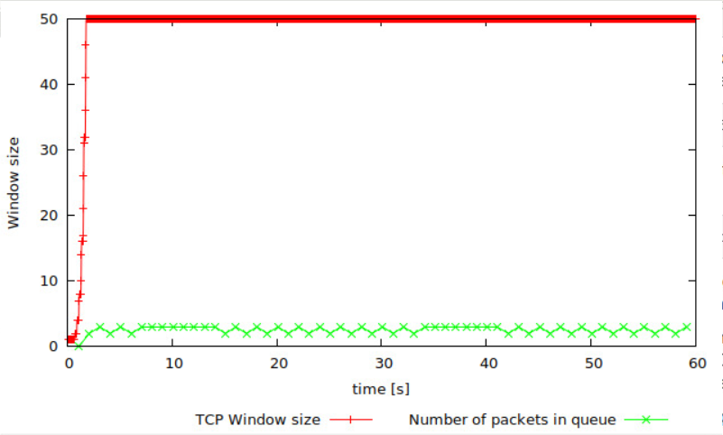

**Here is the throughput when the congestion window size = 50:**

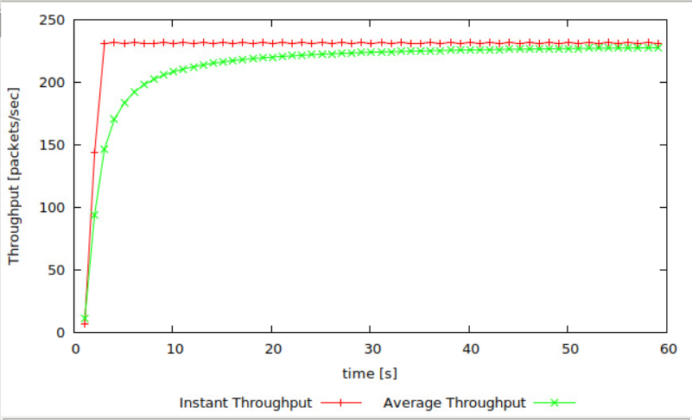

**TCP Tahoe vs TCP Reno**

Recall that, so far we have observed the behaviour of TCP Tahoe. Let us now observe the difference with TCP Reno. As you may recall, in TCP Reno, the sender will cut the window size to 1/2 its current size if it receives three duplicate ACKs. The default version of TCP in ns-2 is TCP Tahoe. To change to TCP Reno, modify the Window.tcl OTcl script. Look for the following line:

set tcp0 [new Agent/TCP]

and replace it with:

set tcp0 [new Agent/TCP/Reno]

Question 4: Repeat the steps outlined in Question 1 and 2 (NOT Question 3) but for TCP Reno. Compare the graphs for the two implementations and explain the differences. (Hint: compare the number of times the congestion window goes back to zero in each case). How does the average throughput differ in both implementations?

**Note:**Remember to include all graphs in your report.

**Answer: We can get the graph below:**

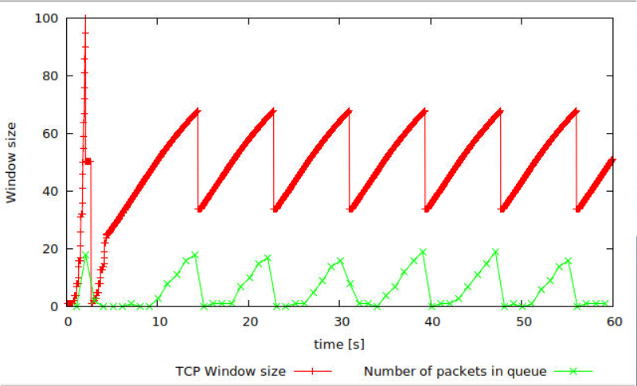

**From this graph, we can find that the TCP doesn’t always enter slow start phase. Instead, the sender halves its current congestion window and increases its linearly, until losses starts occurring again. This pattern repeats. This means most of the losses are detected due to triple duplicate ACKs (not timeout). If timeout appears, the window size will reduce to 1 and then enter slow start phase. This behavior is different from TCP Tahoe whose window size is reduced to 1 after each congestion event (both timeout and triple duplicate ACKs).**

**As for throughput, here is the graph about average and instant throughput:**

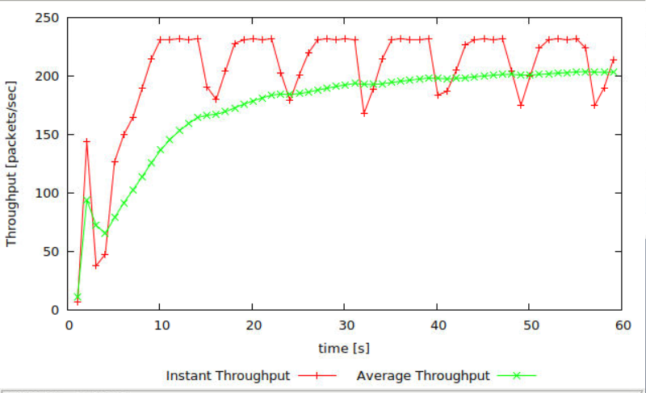

**The throughput of TCP Reno is around 200 packets per sec. It is higher than TCP Tahoe (which is 190 packets per sec). This is because TCP Reno doesn’t need to enter slow start phase after each congestion event again and again(unlike TCP Tahoe).**

Exercise 2: Flow Fairness with TCP

In this exercise, we will study how competing TCP flows with similar characteristics behave when they share a single bottleneck link.

The provided script, [tp_fairness.tcl](https://webcms3.cse.unsw.edu.au/COMP3331/18s2/resources/17319)generates 5 source-destination pairs which all share a common network link. Each source uses a single TCP flow which transfers FTP traffic to the respective destination. The flows are created one after the other at 5-second intervals (i.e., flow *i+1*starts 5 seconds after flow *i*for *i*in *[1,4]*). You can invoke the script as follows

$ns tp_fairness.tcl

The figure below shows the resulting topology; there are 5 sources (2,4,6,8,10), 5 destinations (3,5,7,9,11), and each source is sending a large file to a single destination. Node 2 is sending a file to Node 3, Node 4 is sending a file to Node 5, and so on.

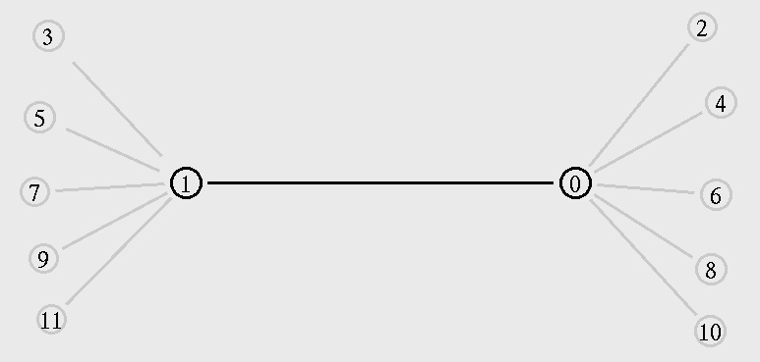

The script produces one output file per flow; farinessMon *i*.tr for each *i*in *[1,5]*. Each of these files contains three columns:

time | number of packets delivered so far | throughput (packets per second)

You can plot the throughput as a function of time using the provided gnuplot script, [fairness_pps.plot](https://webcms3.cse.unsw.edu.au/COMP3331/18s2/resources/17320), as follows:

$gnuplot fairness_pps.plot

**NOTE:**The NAM visualiser is disabled in the script. If you want to display the NAM window (graphical interface), modify tp_fairness.tcl and uncomment the fifth line of the 'finish' procedure:

proc finish {} {

global ns file1 file2

$ns flush-trace

close $file1

close $file2

#exec nam out.nam &

exit 0

}

Run the above script and plot the throughput as a function of time graph and answer the following questions:

Question 1: Does each flow get an equal share of the capacity of the common link (i.e., is TCP fair) ? Explain which observations lead you to this conclusion.

**Answer: After all 5 connections are opened (about 20 seconds), the throughput for all 5 connections is similar although there are still some fluctuations. This is because TCP uses the AIMD congestion control algorithm. These several flows share a bottleneck link and the AIMD makes them achieve long-term fairness by changing the window size. Since they experience the same network conditions, it will react in the same way.**

Question 2. What happens to the throughput of the pre-existing TCP flows when a new flow is created? Explain the mechanisms of TCP which contribute to this behaviour. Argue about whether you consider this behaviour to be fair or unfair.

**Answer: From this graph, we can find that when a new flow is created, the throughput of all pre-existing TCP flows are reduced, especially for the flow:2-3. This is because this new flow uses slow start strategy and it will ramp up quickly and will create congestion on the link. Therefore, all existing TCP connection may detect losses through duplicate ACKs or timeout and change the congestion window size in order to avoid congestion. I think this behavior is fair, since once a new flow is created, the fair share of all existing flows should be reduced.**

**Note:**Remember to include all graphs in your report.

**Here is the throughput for the 5 TCP connections:**

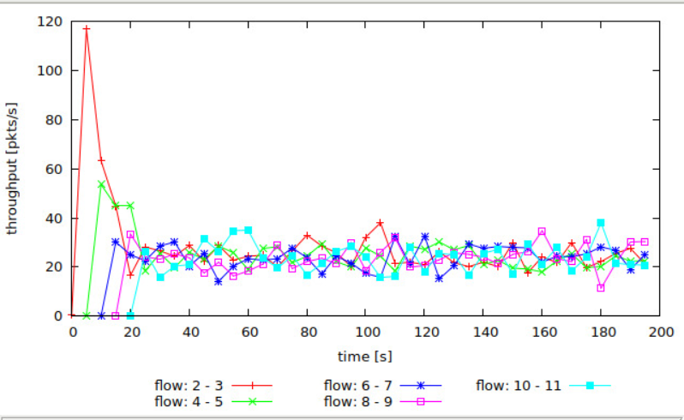

Exercise 3: TCP competing with UDP

In this exercise, we will observe how a TCP flow reacts when it has to share a bottleneck link that is also used by a UDP flow.

The provided script, [tp_TCPUDP.tcl](https://webcms3.cse.unsw.edu.au/COMP3331/18s2/resources/17322), takes a link capacity value as a command line argument. It creates a link with the given capacity and creates two flows which traverse that link, one UDP flow and one TCP flow. A traffic generator creates new data for each of these flows at a rate of 4Mbps. You can execute the simulation as follows,

$ns tp_TCPUDP <link_capacity>

After the simulation completes, you can plot the throughput using the provided gnuplot script, [TCPUDP_pps.plot](https://webcms3.cse.unsw.edu.au/COMP3331/18s2/resources/17323), as follows,

$gnuplot TCPUDP_pps.plot

Question 1: How do you expect the TCP flow and the UDP flow to behave if the capacity of the link is 5 Mbps ?

Now, you can use the simulation to test your hypothesis. Run the above script as follows,

$ns tp_TCPUDP 5Mb

The script will open the NAM window. Play the simulation. You can speed up the simulation by increasing the step size in the right corner. You will observe packets with two different colours depicting the UDP and TCP flow. Can you guess which colour represents the UDP flow and the TCP flow respectively ?

**Answer: Since UDP doesn’t use any congestion control unlike TCP, UDP flow will not reduce its transmission rate when congestion appears. Therefore, we can clearly find that red flow is UDP and relatively less blue flow if TCP.**

You may disable the NAM visualiser by commenting the "exec nam out.nam &' line in the 'finish' procedure.

Plot the throughput of the two flows using the above script (TCPUDP_pps.plot) and answer the following questions:

Question 2: Why does one flow achieve higher throughput than the other? Try to explain what mechanisms force the two flows to stabilise to the observed throughput.

**Answer: As expected, since UDP doesn’t use any congestion control, UDP achieves higher throughput than TCP. It transmits packets at a constant rate, regardless of whether any of packets get dropped. It is unfair to TCP flow because TCP will reduce its transmission rate when it detects congestion in the network. The UDP flows may make TCP flows transmit rate become very low when they traverse the same bottleneck links.**

Question 3: List the advantages and the disadvantages of using UDP instead of TCP for a file transfer, when our connection has to compete with other flows for the same link. What would happen if everybody started using UDP instead of TCP for that same reason?

**Answer:**

**Advantage: The sender could keep transmitting unrestrained, regardless of congestion. This may potentially reduce the delay for transferring files. (but not always, because when the transmitting rate is much higher than link capacity, it will still be more serious congestion and eventually it will cause delay)**

**Disadvantage: Since UDP is an unreliable data transfer protocol, the files transfer protocol running over the UDP have to use reliable data transfer.**

**If everyone uses UDP instead of TCP, when faced with congestion, every sender still sends lots of data which can make network’s congestion become more serious and congestion situation can’t be improved. Also, every above protocol using UDP should have a mechanism to guarantee reliable data transfer.**

**Note:**Remember to include all graphs in your report.

**Here is the graph about throughput for the two flows.**

